**Name: Heet Patel**

**Roll number: 24BPEO74**

**Branch: Petroleum**

**Semester: 2nd**

**Division: 2**

**Batch: P3**

**Lab: 2**

QUESTION 1: Print largest and smallest values out of two.

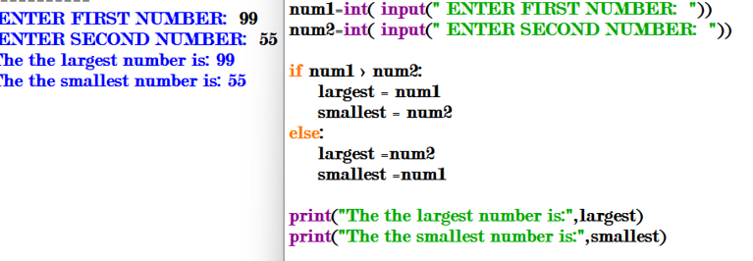

QUESTION 2: Print largest and smallest values out of three

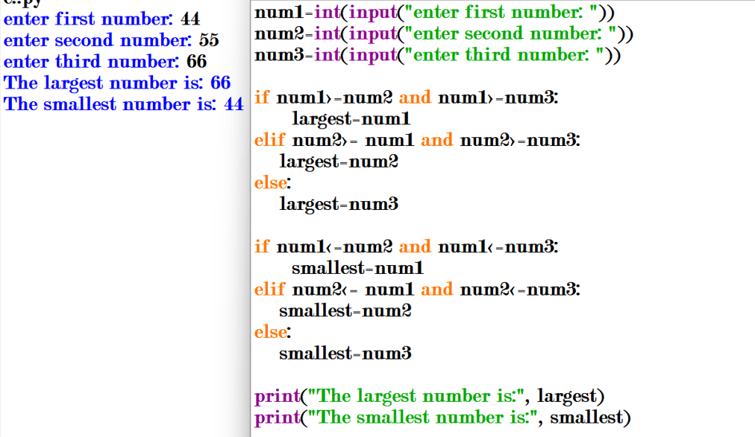

QUESTION 3:” Check whether a given number is odd or even

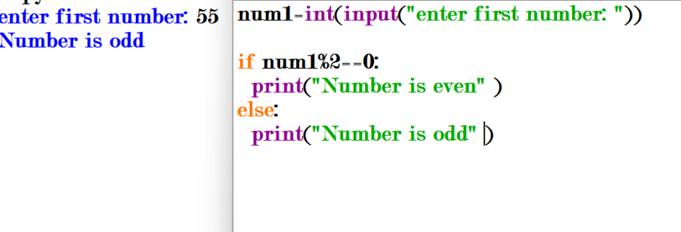

QUESTION 4: Check whether a given number is divisible by 10 or no

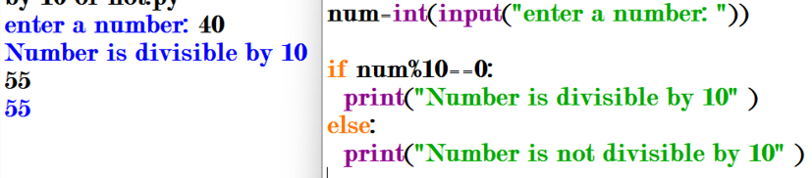

QUESTION 5: Accept age of a person. If age is less than 18, print minor otherwise Major.

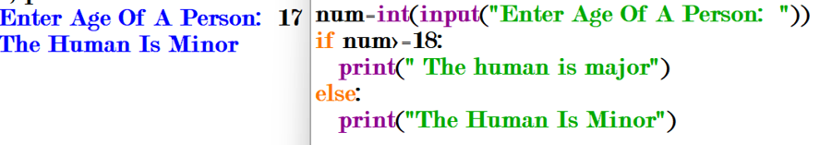

QUESTION 6: Accept a number from the user. And print number of digits in it.

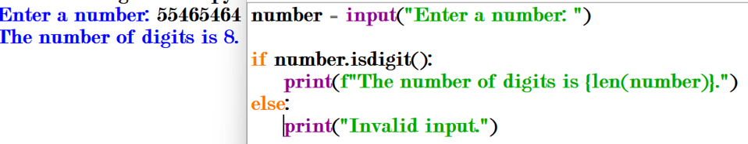

QUESTION 7: Accept a year value from the user. Check whether it is a leap year or not

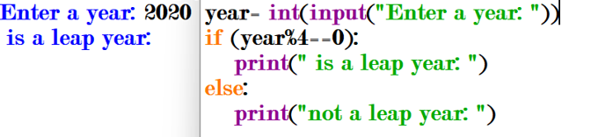

QUESTION 8: Check whether a triangle is valid or not, when the three angles of the triangle are entered through the keyboard. A triangle is valid if te sum of all the three angles is equal to 180 degrees

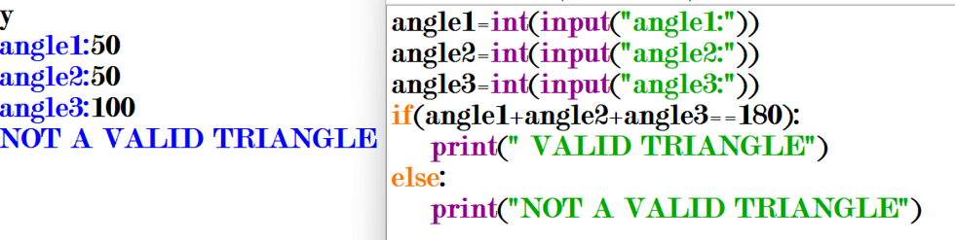

QUESTION 9: Print absolute value of a given number

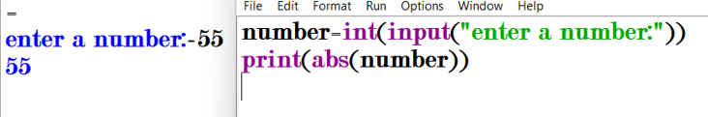

QUESTION 10: Given the length and breadth of a rectangle, write a program to find whether the are of the rectangle is greater than its perimeter

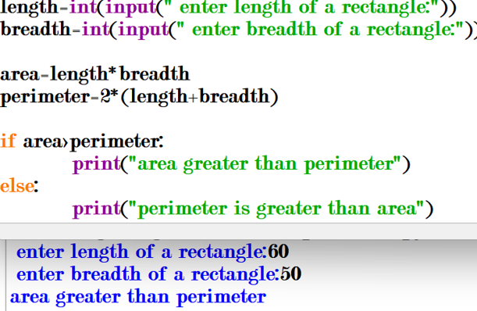

QUESTION 11: Given three points (x1,y1), (x2,y2) and (x3,y3), check if all the three points fall on one straight line.

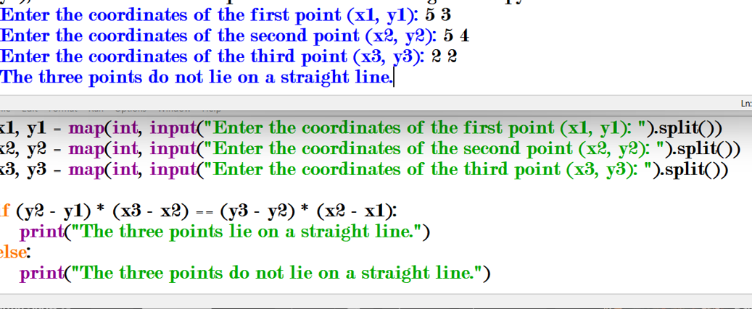

QUESTION 12: Given the coordinates (x,y) of center of a circle and its radius, determine whether a point lies inside the circle, on the circle or outside the circle. (Hint: Use sqrt( ), pow( ) )

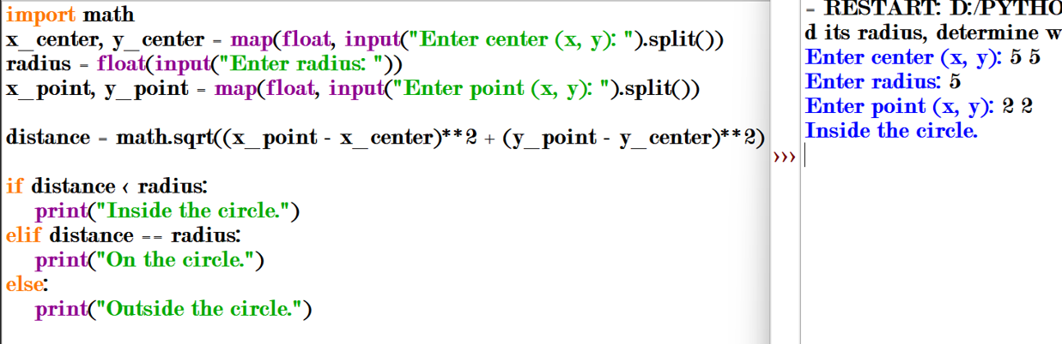

QUESTION 13: Convert number 0 to 19 to its equivalent words. E.g. 0 zero, 19 nineteen.

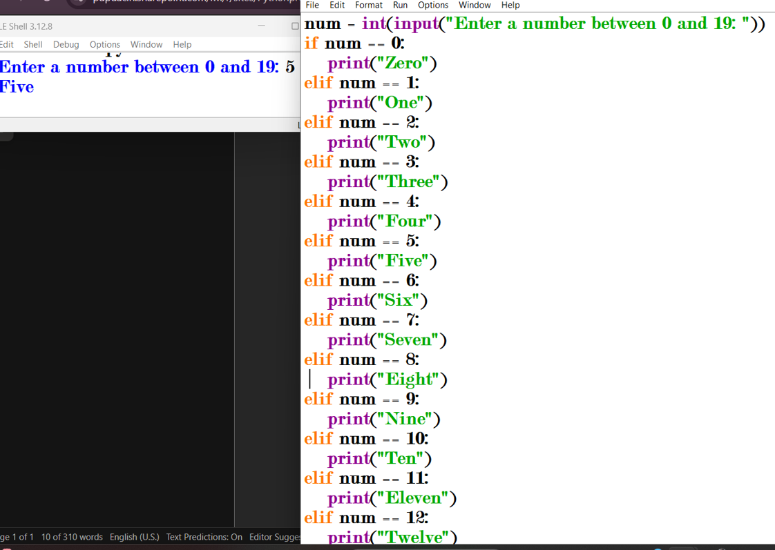

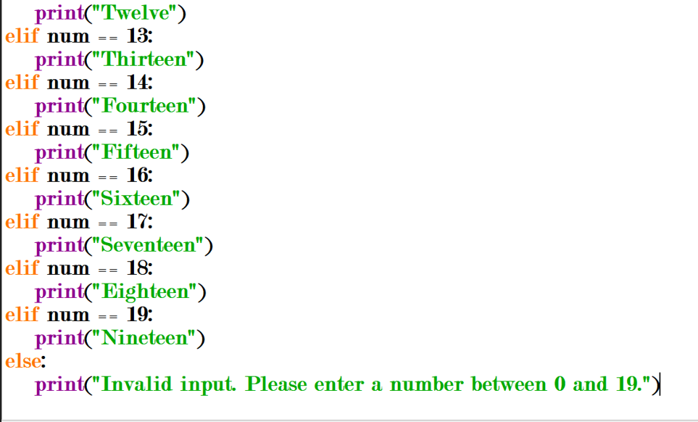

QUESTION 14: Accept marks of three subjects. Print total and average along with whether a candidate has passed or fail. If student secures <= 39 marks in any subject, consider him as fail. Also assigned a subject wise grade based on the following table:

|  |  |
| --- | --- |
| Marks Range | Grade |
| Absent | NA |
| 0 – 39 | F |
| 40 – 44 | P |
| 45 – 49 | C |
| 50 – 54 | B |
| 55 – 59 | B+ |
| 60 – 69 | A |
| 70 – 79 | A+ |
| 80 – 100 | O |

